GUI TESTING

**DISCIPLINARY CODE**

* Show policy button works.
* Adding/editing actions work properly
* Correct error messages appear when multiple of the same action is made

Problems with GUI code:

* The spelling on the interface is appalling.
* 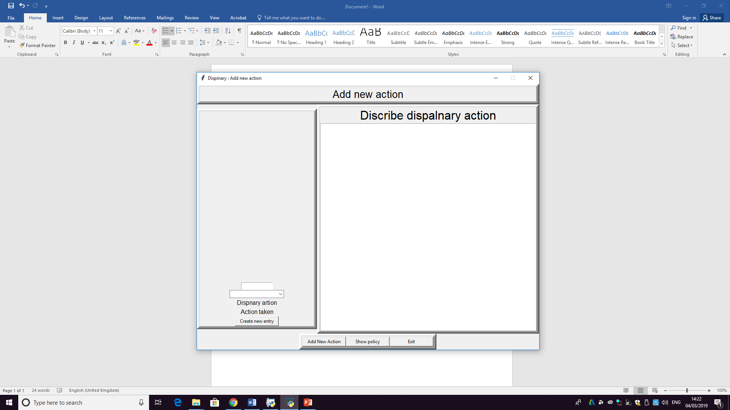
* The layout of the buttons could be improved to be more organised and easy to follow and more obvious to the user.
* Label the boxes.

**OFF BOARDING ON BOARDING**

* 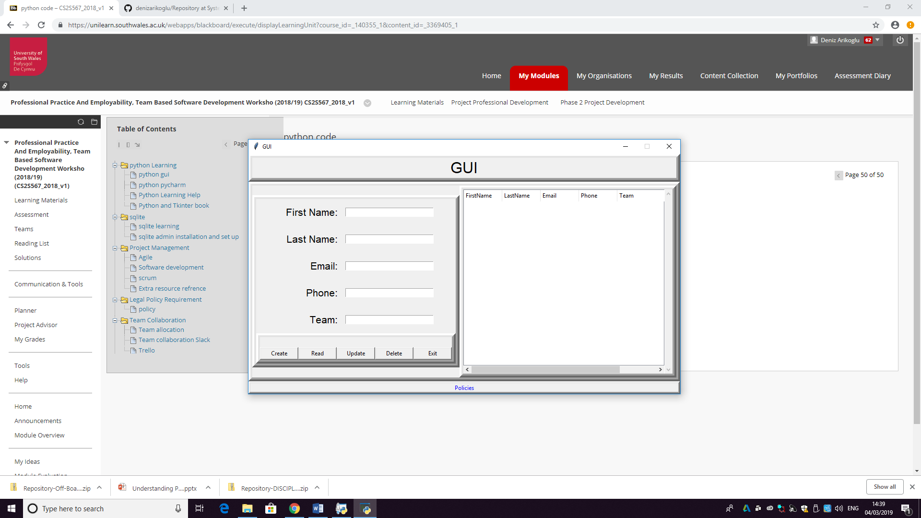
* So this is a great piece of code that almost fully works.
* The design is simple and clean.
* And does as you expect it to work.
* Good use of error messages.
* Policies are very clear and well put together.
* I couldn’t log on to join all the separate codes together but everything else works individually without any problems.
* 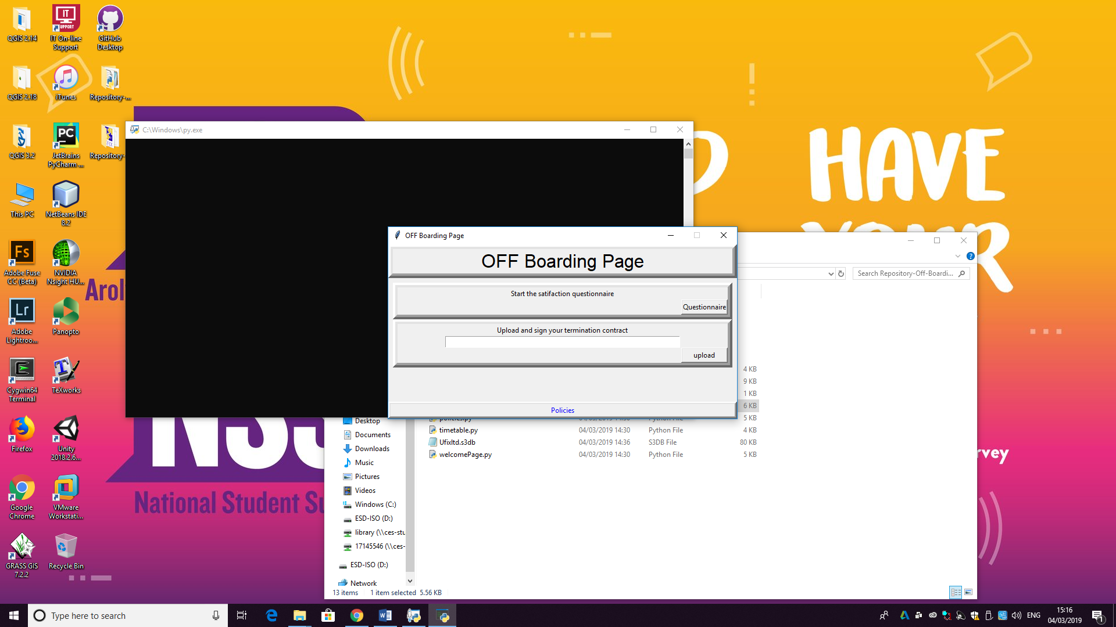

PERSONAL INFORMATION MANAGEMENT

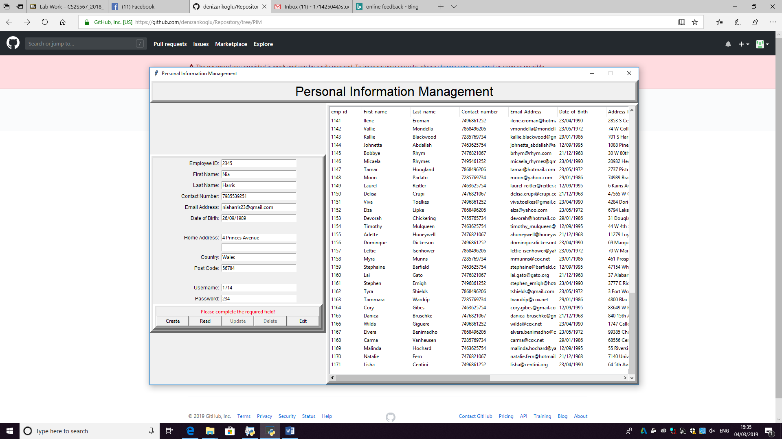

* Read button works – able to view the database of all current employees.
* Unable to add a new employee due to not having a password
* Exit button works – good use of error message before program shuts.

RECRUITMENT

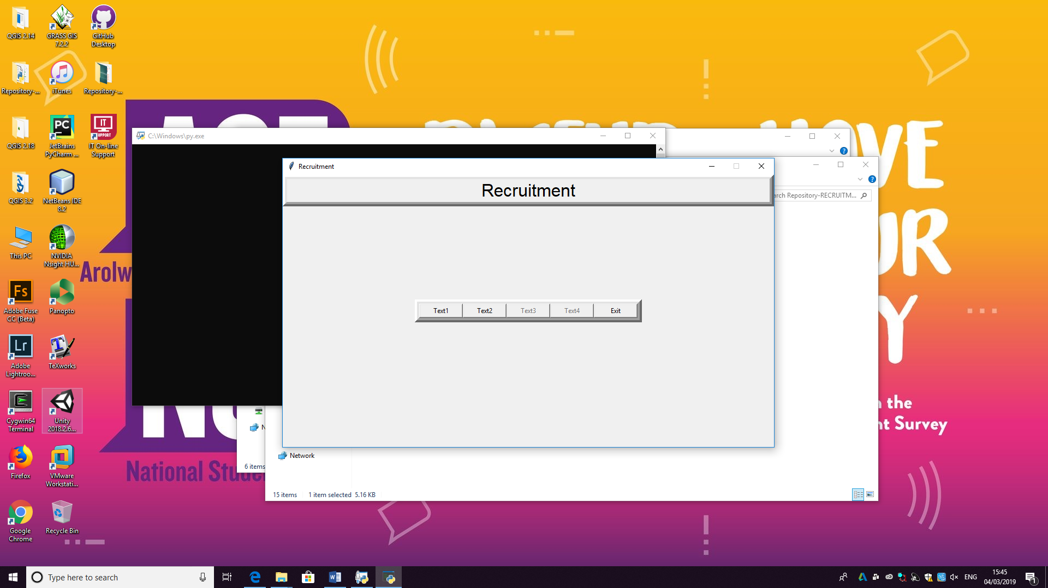

* EXIT button works – good use of error message before program shuts.
* No other buttons work.